The pandemic's lasting impact on golf
We look at how two years of the COVID-19 pandemic have set the game on a new course.
Jason Scott Deegan
March 17, 2022

When the PGA Tour canceled The Players Championship on March 12, 2020, the world of golf changed forever.
At the time, the onset of the COVID-19 pandemic caused incredible uncertainty and upheaval of life as we knew it. This perpetual state of chaos still remains in many ways. Here we are, just over two years later, and the world has definitely changed. Golf was one of the lucky industries to not only survive but thrive during the pandemic.
It was hard to envision such a dramatic turnaround when, pre-pandemic, so many major media outlets were writing golf's obituary. After two decades of gloom and doom - highlighted by course closures and unsold tee times - it's refreshing to think that the game's future just might be brighter than even the most starry-eyed optimist could have foreseen. The pandemic changed golf for the better. Let's look at how:

Renewed passion for the game
One of the lasting lessons of the pandemic is to not take anything for granted. Don't miss the chance to enjoy the little things like playing golf with friends. The new mantra of getting outside and limiting screen time has never been stronger. The 18 months where golf was the only game in town in place of restaurants, sporting events (youth and pro) and travel helped introduce the game to the next generation. They found out golf wasn't grandpa's stuffy country club they had stereotyped it to be.
The National Golf Foundation reports that total number of golfers worldwide has reached 66.6 million, up from 61 million five years ago. Statistics point to nice gains attracting women and minorities. The NGF stats indicate that women now comprise 25% of golfers, and people of color 21%, both groups having increased meaningfully in recent years. These demographics have always been the key to sustainable growth. The total number of youth golfers remained stable in 2021, according to NGF, but this cohort’s size has increased by almost 25% over the past three years alone, to more than 3 million, laying a nice foundation for the future.

Tee time wars
This rise in popularity has made it harder to find tee times, especially on weekends and at popular local haunts like munis and other affordable options. I'm a victim just like you. To get a decent tee time on a Friday through Sunday before noon on our favorite muni, my group still has to shop two weeks out when the tee times are released. If we don't, we're stuck with a less desirable time. Even country clubs have felt the squeeze in finding tee times for their members. Waiting lists are back for the most in-demand private clubs.

Green fees on the rise
With a rise in demand comes a rise in price. It's Economics 101. While some golfers are grumbling about the greens fee increases seen across the industry in the past 12 months, the reality is that it's a good thing. Courses are healthier when their owners are stable, making money (at least a little) and have the confidence and cash to invest back into the property.
Unfortunately, the top of the food chain seems to be on an unsustainable pace, and that's a bruise on the perception that the game is affordable and accessible for all. The price to play Shadow Creek ($1,000) and TPC Sawgrass ($840) has skyrocketed, but when your local muni hits golfers with a $2-$4 increase, that's simply a correction for nearly 15 years of discounted tee times and virtually no price hikes in relation to the rising cost of doing business. I tell my friends to pay up with a smile and celebrate the fact that the course survived the past two decades, which was the darkest period in the history of the game when thousands around the country closed.

The way we play has changed
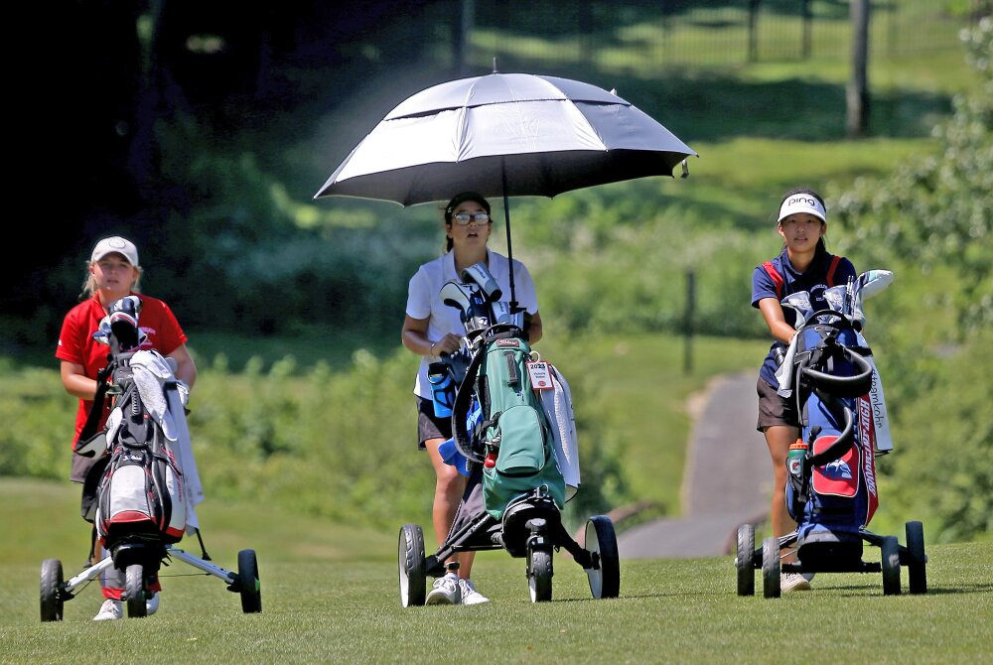
More golfers are walking and using push and pull carts, like these Competitors in a 2021 girls' golf tournament in Massachusetts.Matt Stone/MediaNews Group/Boston Herald

More than 3 million new golfers tried the game for the first time in 2021, according to the NGF. All these new players have brought new perspectives on what they want from the game. Having fun has taken precedent over worrying about shooting a good score and following the rules to a T. Some age-old traditions are slowly changing.
I can't speak for every group, but almost every round I've played the last two years has involved leaving the pin in, playing music and walking. All three things are becoming more and more welcome within the game.
Leaving the flagstick in at all times started in 2019 when the USGA changed rule 13.2a, leaving the option up to the player. When the pandemic panic set in, many clubs required golfers to leave the pin in for fear of transferring the virus. People got more comfortable putting that way the more they tried it. Now, long-time proponents like data cruncher/instructor Dave Pelz and influential golf writer/editor George Peper can rejoice that the next generation might mess with the flag less. No tending it. No worrying about when to pull it. No hassles in trying to figure out where to put it. Count me in the camp that believes this speeds up play. Ryder Cuppers Bryson DeChambeau (on longer putts) and England's Matthew Fitzpatrick often keep the stick in. Seeing pros do it also influences popular opinion.
More golfers are walking for the simple fact that they want some exercise during their rounds. When courses made carts available to only one player at a time during the height of the pandemic, many golfers went out and bought push and pull carts, setting off a supply shortage that's still ongoing. I love the feeling of a little huffing and puffing between shots. It makes me feel less guilty for spending 4-5 hours away from the family and work responsibilities. I'm taking care of my health, both physical and mental.
Even the music makes a difference. It keeps my energy and mood up, even when the bogey train is gaining steam. Weird as it seems, the pandemic has made golf fun again. The game's momentum is palpable. Let's all enjoy the high tide. Who knows how long it will last.

